EC DECLARATION OF CONFORMITY
THIS IS HEREBY DECLARED THAT FOLLOWING DESIGNATED PRODUCT COMPLIED WITH THE ESSENTIAL HEALTH AND SAFETY REQUIREMENTS OF Machinery Directive (MD) 2006/42/EC & LOW VOLTAGE DIRECTIVE (LVD) 2014/35/EU&ELECTROMAGNETIC COMPATIBILITY DIRECTIVE (EMC) 2014/30/EU ON THE APPROXIMATION OF THE LAWS OF THE MEMBER STATES RELATING TO IT.

MANUFACTURER
ZHEJIANG IWALK TECHNOLOGY CO., LTD.
NO. 59 JUXING TECHNOLOGY PARK, JIAOJIANG DISTRICT, TAIZHOU CITY, ZHEJIANG PROVINCE, CHINA

NAME AND ADDRESS OF PERSON AUTHORIZED TO COMPILE THE TECHNICAL FILE
LUCKY TRANSPORT EURO KFT
1085 Budapest, JÓZSEF KÖRÚT 69.FSZT.1
Email: eurep.office@gmail.com

DESCRIPTION OF MACHINERY
PRODUCT NAME: Electric Scooter
MODEL TYPE: KS1

APPLICABLE STANDARDS
EN ISO 12100:2010, EN 60204-1:2018, EN 17128:2020,
EN IEC 61000-6-1:2019, EN 61000-6-3:2007+A1:2011,
EN IEC 61000-3-2:2019, EN 61000-3-3:2013+A1:2019

THIS DECLARATION APPLIES TO ALL SPECIMENS MANUFACTURED IDENTICAL TO THE MODEL SUBMITTED FOR TESTING / EVALUATION. ASSESSMENT OF COMPLIANCE OF THE PRODUCT WITH THE REQUIREMENTS RELATING TO SAFETY STANDARDS LISTED ABOVE WAS PERFORMED BY MANUFACTURE.

SIGNED ON BEHALF OF ZHEJIANG IWALK TECHNOLOGY CO., LTD.
Bruce Yang


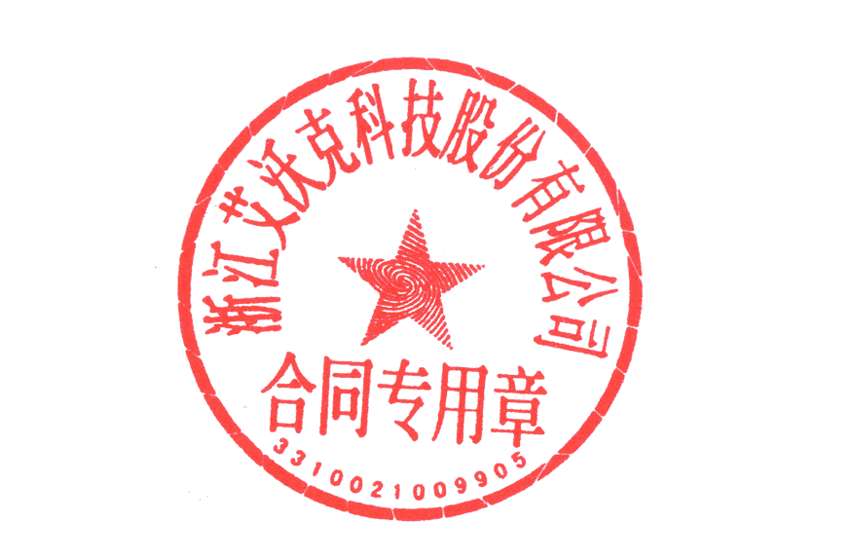
SIGNATURE
General Manager
TITLE
TAIZHOU,ZHEJIANG ,CHINA
PLACE
2022.7.7
DATE

