**Fly Under The Radar**

OWNERS MANUAL

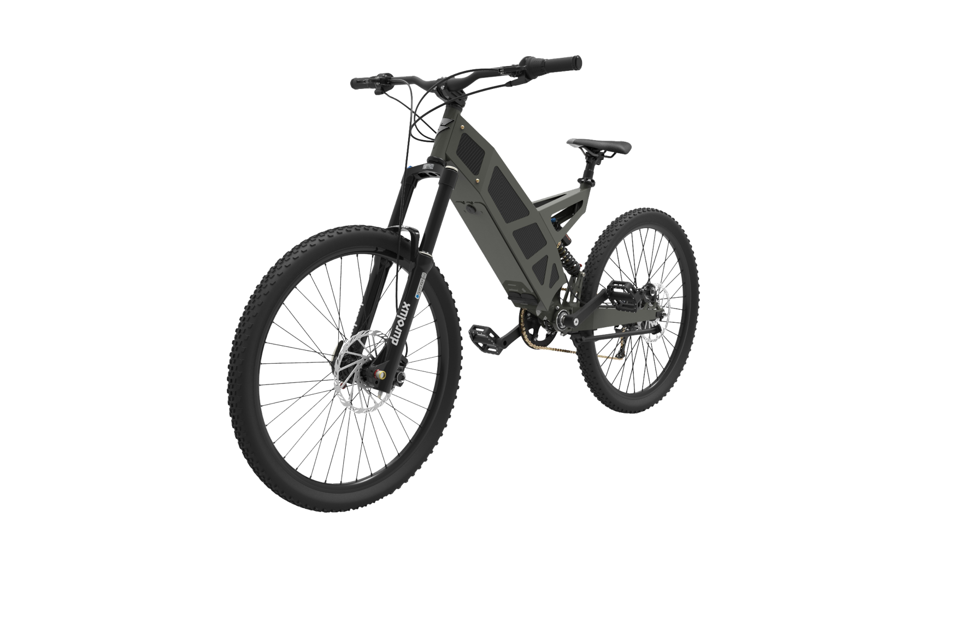**V2.6 2021**

****P-7R | P-7

Please read entire manual before riding your Stealth Electric Bike



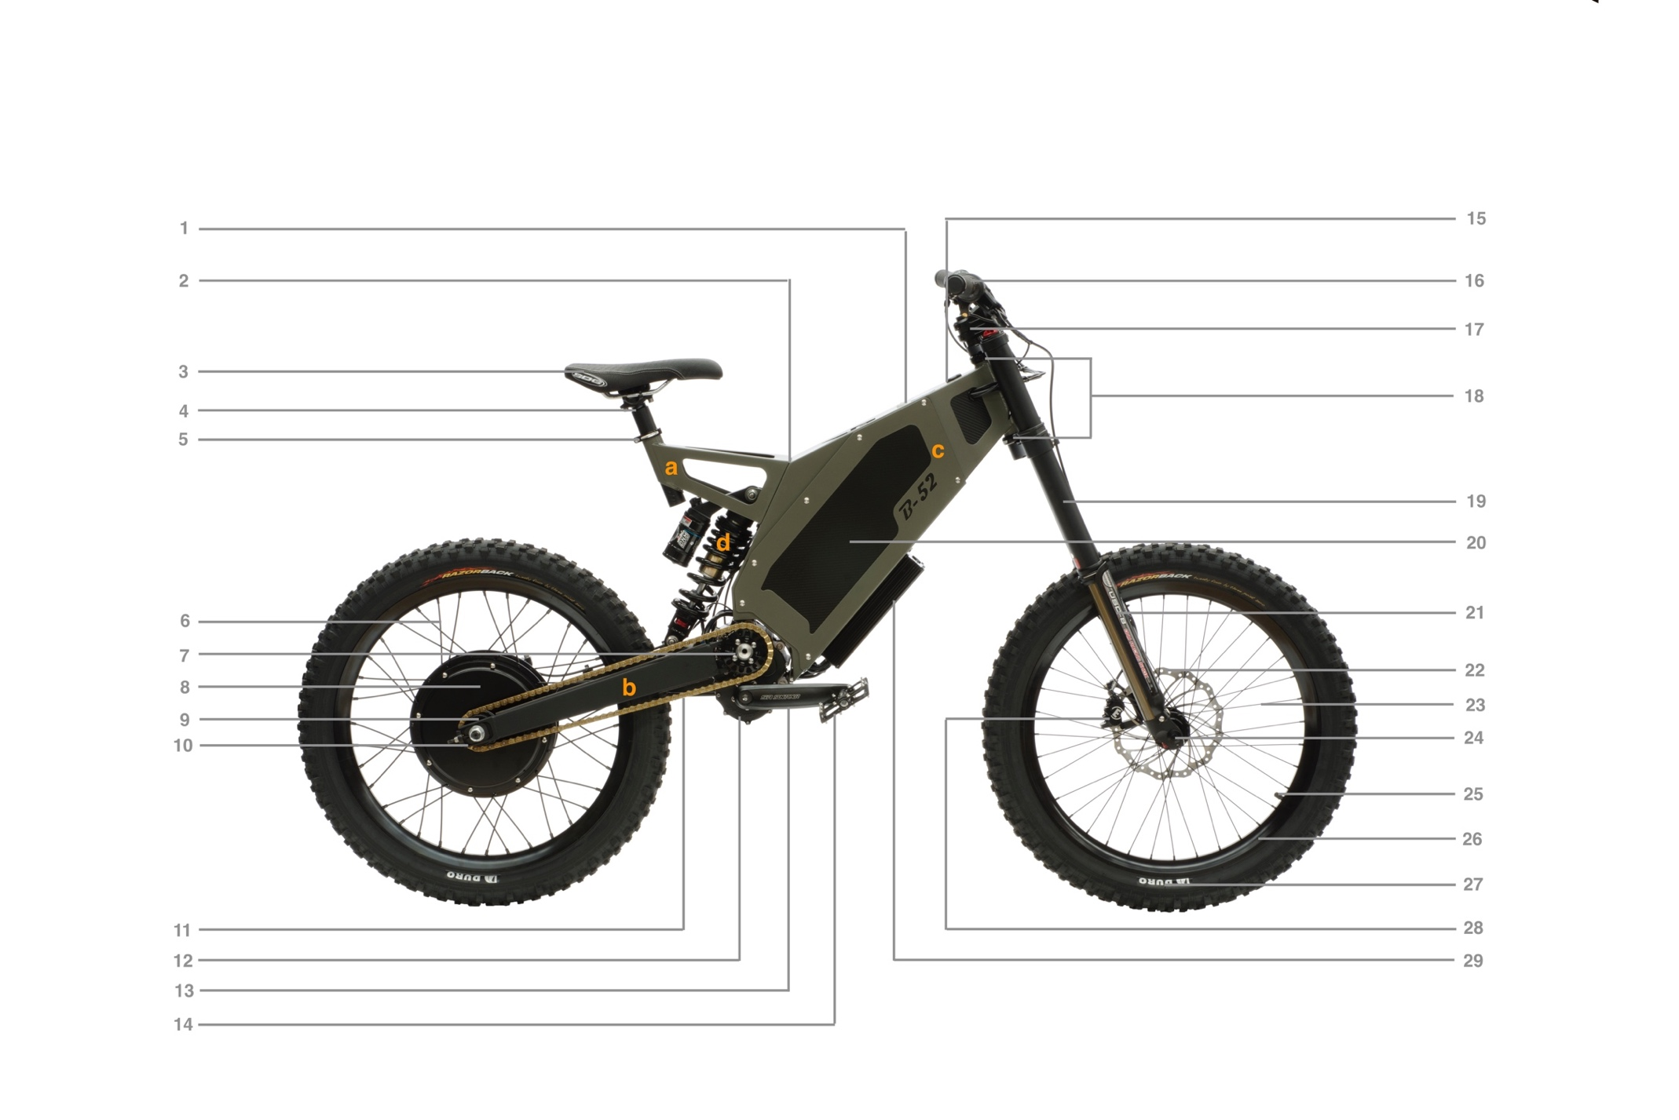**Components**

1. DC-1 Display
2. Frame:
3. Subframe
4. Swingarm
5. Side cover
6. Rear shock
7. Saddle
8. Seat post
9. Seat post clamp
10. Rear spokes
11. Chainring/V-Boxx Sprocket
12. Hub Motor
13. Freewheel
14. Chain tensioner/torque plate
15. Chain
16. Suntour V-Boxx
17. Crank set
18. Pedals
19. Key switch
20. Controls
21. Handlebar
22. Gear selector
23. Throttle
24. Regen button
25. Grips
26. Brake levers
27. Stem
28. Headset
29. Forks
30. Battery
31. Fork protectors
32. Disc rotor
33. Front spokes
34. Front axle
35. Tube and valve
36. Rim
37. Tyre
38. Brake caliper
39. Speed controller

**Table of Contents**

2 Welcome

3 Product Registration

3 General Notes and Warning

4 Assembly

4 Out of the crate

4 Torque specifications

5 Install the handlebars

5 Install the front wheel

6 Install the pedals

6 Install the seat & seat post

6 Inflate the tyres

7 Install the battery – B-52, H-52 & F-37

7 Install the battery – P-7R & P-7

8 Install DC-1 Jumper

8 Battery

8 Range

9 Charging

9 Storing battery and Stealth bike for long periods

10 Your First Ride

10 Braking

10 Regen Braking

10 Throttle

11 Selecting gears – B-52

11 Selecting gears – F-37

11 Selecting gears – P-7R & P-7

11 Adjusting suspension

11 Comfort and bike position

12 DC-1 and electronic security

12 Electronic security

12 DC-1 screens – Home

13 DC-1 screens – Info

14 DC-1 screens – Settings   
14 While riding

15 Trip information

15 Manual limits

15 Automatic limits

15 Competition mode

16 Riding Techniques

16 Avoiding damage

16 Off road riding

16 Riding efficiently

17 Stealth bike care

17 Cleaning

19 Maintenance Schedule

19 Every ride

19 Every month

19 Every six months

19 Troubleshooting

19 BMS reset procedure

20 Appendix 1: Component Manuals

20 Limited Warranty

**Welcome**

Welcome to the Stealth Electric Bike community and congratulations on your purchase.

Stealth Electric Bikes redefine the ride experience. They are considered by peers to be the world’s toughest and most powerful hybrid electric bikes.

Featuring heavy duty suspension, 2-hour charge time, silent operation and zero emissions, using your Stealth Electric Bike will turn every ride into an adventure.

Stealth Electric Bikes manufacture a range of e-bikes so this manual may contain some information that does not apply to your bike. Some illustrations may vary from your actual bike.

If you have any questions after reading the information in this manual, consult your local dealer.



**IMPORTANT**:

**This manual contains important safety, performance and service information. Read it before you take the first ride on your new Stealth Bike, and keep it for future reference.**

Additional safety, performance and service information for specific components such as transmission, suspension or brakes on your bike may also be available.

Make sure that your dealer has given you all the manufacturers’ literature that was included with your bike or accessories. In case of a conflict between the instructions in this manual and information provided by a component manufacturer, always follow the component manufacturer’s instructions.

To the best knowledge of Stealth Electric Bikes, the material contained herein is accurate as of the date this publication was approved for printing. Stealth Electric Bikes reserves the right to change specifications, equipment, or designs at any time without notice and without incurring obligation. Illustrations in this manual are merely for demonstration purposes and may not exactly match the detail described.

**NOTE**: This manual is not intended as a comprehensive use, service, repair or maintenance manual. Please see your dealer for all service, repairs or maintenance. Your dealer may also be able to refer you to classes, clinics or books on bike use, service, repair or maintenance.

**Product Registration**

To receive full warranty support, you must completely fill out the online warranty registration form upon receiving your bike.

This can be found at: <https://stealthelectricbikes.com/warranty-registration/>

To read Stealth Electric Bikes current limited warranty and related warranty claims information please see the terms at the end of this manual.

Warranty policies vary depending upon the Stealth Distributor in the country of your purchase. Please check with your Stealth Dealer or the Stealth Distributor in your country for the warranty policy covering your purchase.

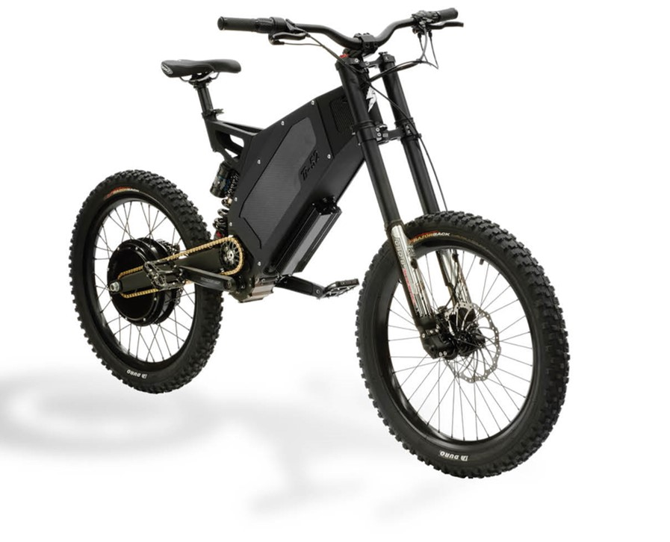

**General Notes and Warning**



Action sports involve a risk of injury or death. In choosing to ride a Stealth Bike, you accept that risk and take responsibility to learn and practice safe and responsible riding.

This e-bike is sold with a limited warranty against defective workmanship. In some countries, it does not conform to federal motor vehicle safety standards and operation on public roads, streets or highways and consequently may be illegal to operate. Before operating this vehicle, first determine that its use is legal in that given area. It’s your responsibility to familiarize yourself with the laws of the areas where you ride, and to comply with all applicable laws.

The bike is designed and constructed as an operator only model. The load limit and seating configuration does not safely permit the carrying of passengers.

Do not ignore any warnings displayed in this manual. They indicate a potentially hazardous situation which, if not avoided, could result in death or serious injury.

**Assembly**



Stealth Electric Bicycles should only be assembled by a skilled mechanic. If you are not confident with assembling the bike yourself please contact your nearest dealer for assistance.

The bike must be assembled in a safe workspace that is free of volatile materials, water, unauthorized personal and tripping hazards.

Ensure that the power is switched off and the battery/motor cables are disconnected.

**OUT OF THE CRATE**

Stealth bikes are partially disassembled for packing. Several components must be reassembled before riding.

Batteries are sent separate to the bike for non-Australian customers.

Tools required to assemble the remaining components:

* + A set of metric Hex Keys (2, 2.5, 3, 4, 5, 6, 8, 10mm)
  + A T25 Torx key
  + 15mm pedal spanner
  + Set of ring spanners
  + Calibrated torque wrench with hex key attachments

**TORQUE SPECIFICATIONS**

|  |  |
| --- | --- |
| Front axle | Varies between forks – Check manufacturers specifications |
| Rear axle nuts | 45Nm |
| Stem handlebar clamp | 10Nm |
| Stem steerer tube clamp | 15Nm |
| Crank bolts | 40Nm |
| Pedals | 20Nm |
| Magura brake lever clamps | 4Nm |
| Battery cover fasteners | 4Nm |
| Brake caliper bolts | 6Nm |

**INSTALL THE HANDLEBARS**

The handlebars come from the factory with all controls installed and ready. Ensure that a torque wrench is used when tightening bolts so that the correct torque value is reached.

1. Remove the 4 bolts on the stem faceplate using a 6mm Allen key.
2. Remove faceplate from stem.
3. Gently and carefully cut tape securing forks to stem and remove bubble wrap.
4. Install handlebars on stem making sure that wires and cables are moving freely and not fouled in any way.
5. Apply grease or threadlocker on bolts and loosely reinstall the faceplate on the stem using the same 4 bolts.
6. Check alignment of handlebars and preferred riding position.
7. Evenly tighten bolts to correct tension in an X pattern (see Torque Specifications table).

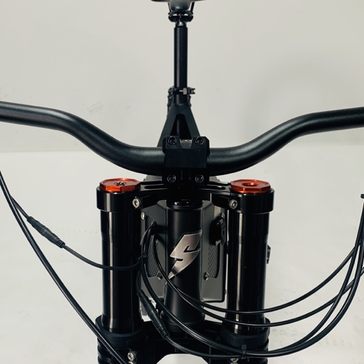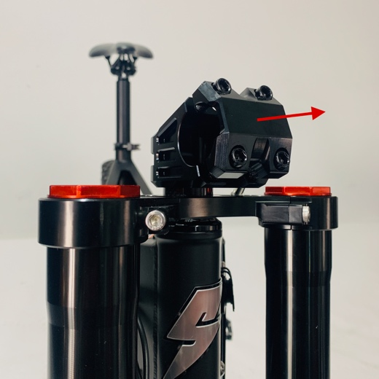

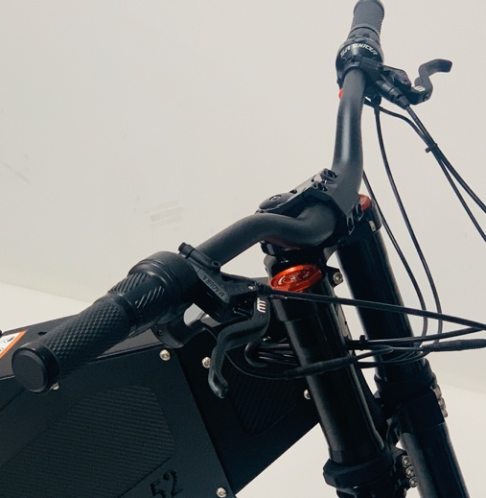

**INSTALL THE FRONT WHEEL**

For ease of transport, your bike may come with the front wheel uninstalled. The 20mm or15mm thru axle needs to be correctly inserted into the dropout when installing the wheel.

**Suntour Forks (Q-Loc Axle):**

1. Check the segmented flange to be expanded before installation and open the lever completely.
2. Slide in the axle until it "clicks". Make sure the segmented flange is expanded.
3. Set the tension of the nut until the flange is flush with the dropout.
4. Close the lever completely. Check if it’s firmly seated. Retighten the nut if necessary.

Check Suntour Manual for more detail and information. Online digital manual found [here](https://www.srsuntour.com/fileadmin/user_upload/Downloads/Consumer/Bike/Owners%20manuals/General_Fork_Manual/EN_MY22_SUS_fork_user_manual-20210820.pdf).

**INSTALL THE PEDALS**

The pedals need to be installed on the correct side. The right-hand crank and pedal have a standard right hand thread and the left side has a left hand thread. The pedals should be tightened by hand first to ensure they are not cross threaded or have the wrong thread. Using a hex key or pedal spanner the pedals can be tightened to the prescribed torque.

Cranks come pre-fitted to bike. The pedals can be fitted using a 15mm pedal spanner.

1. Unpack pedals and separate left from right if labelled. If not labelled, the right pedal always has a standard thread and will only tighten CLOCKWISE into the right crank. The left pedal is the opposite with reverse thread and tightens ANTI-CLOCKWISE.
2. Tighten pedals on to their respective cranks using an 8mm Allen key if there is no surface for a 15mm pedal wrench.

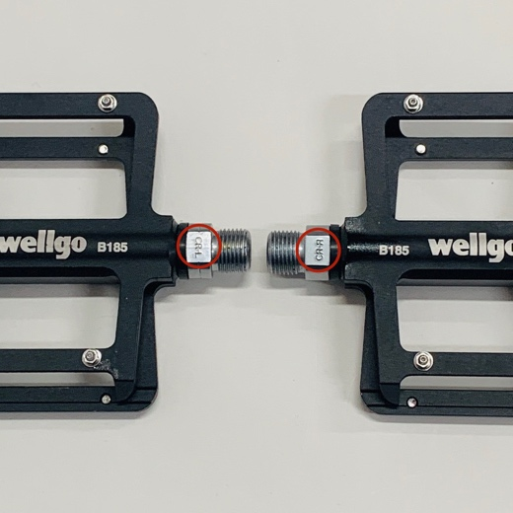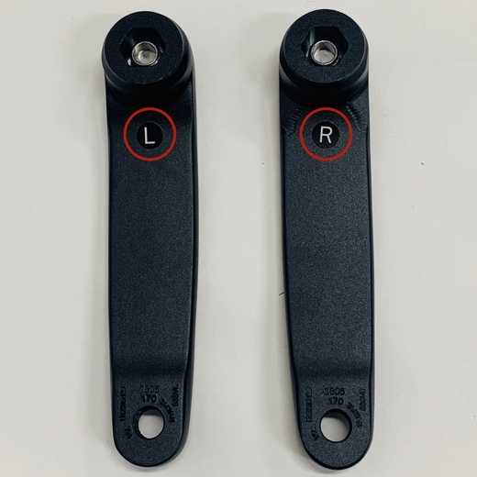

L and R pedals

L and R cranks

**INSTALL THE SEAT & SEAT POST**

The supplied seat posts are extra-long and suitable for taller riders. Shorter riders may find that they need to cut the length of the seat post to avoid contact with the rear shock. Avoid contact between the shock spring and the seat post and make sure that the shock will not contact the seat post when the suspension is fully compressed.

1. Bolt the seat to the post loosely.
2. Slide the seat post into the seat tube and adjust the height accordingly.
3. Adjust the tilt of the seat back and forth using the adjusters located on the seat post.
4. Tighten all bolts. Ensure that there is always a minimum of 50mm of overlap between the seat post and the seat tube (frame).
5. Check that the seat post will not collide with shock under full compression before riding, ensure a 5mm gap between the bottom of the seat post and rear shock.

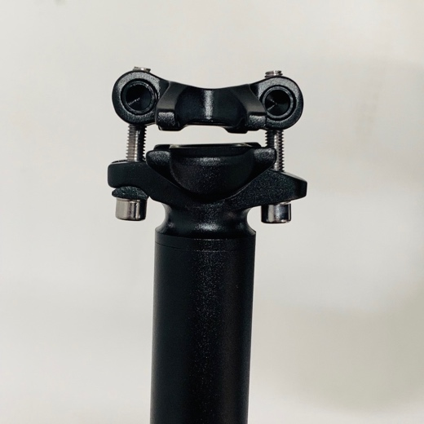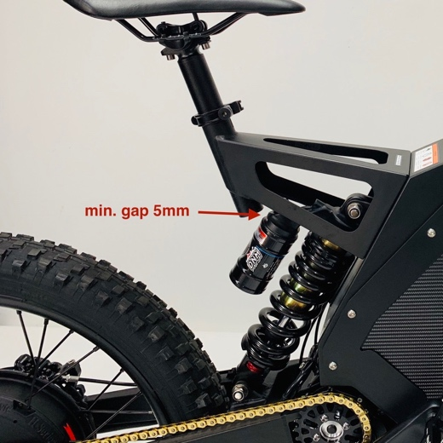

Seat post fittings

**INFLATE THE TYRES**

Tyres should be inflated no greater than the maximum recommended pressure printed on the sidewall of the tire. Periodically check the wear and tear on the tyres and replace if damaged.

**INSTALL THE BATTERY**

If your battery has been shipped to you separately you will need to install the battery into the bike. You will need to remove the side covers to gain access to the battery compartment.



Ensure key is removed when performing any work on bike. Accidental acceleration of bike may cause serious personal injury.

Follow these steps below to fit your battery:

The P-7 and P-7R chassis and design slightly differs from the other bikes. The battery compartment of the frame is accessed from the downside of the bike.

Follow these steps below to fit your battery:

1. 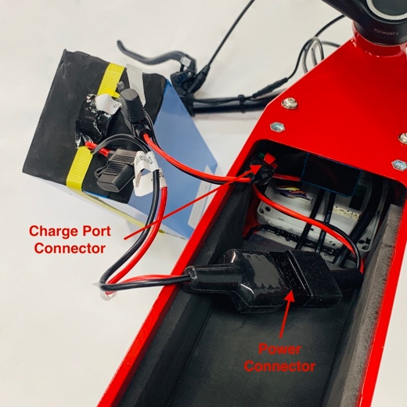Carefully turn the bike upside down so that it is resting on its handlebars and seat. This will allow for easier installation.
2. The Battery for the P-7 can be accessed from underneath the frame by removing the retaining plate held on by 4 surrounding bolts (4mm).
3. Given the space restrictions, now is a good time to connect the battery to the bike. The main connector simply pushes together. When connecting the charge port, be sure that the correct connection is made and that the red and green connectors line up. Install locking pin so that the plug does not detach.
4. Carefully insert the battery into the frame. Pay close attention to the cables and ensure none are pinched, pulled, bent or compressed in the process.
5. Avoid installing the battery at an angle. It should fit snugly in the P-7 frame and fairly level. Ensure the battery does not protrude past the frame and is sitting towards the back of the bike.
6. All wires, brake lines and gear cables should run below the battery. A rubber gasket will sit between the battery and battery cover. NOTE: There is a slight curve on the battery cover which helps keep pressure on the rubber gasket – see photo below.
7. Secure the battery cover, also ensure the bolts have Loctite applied and are torqued correctly.

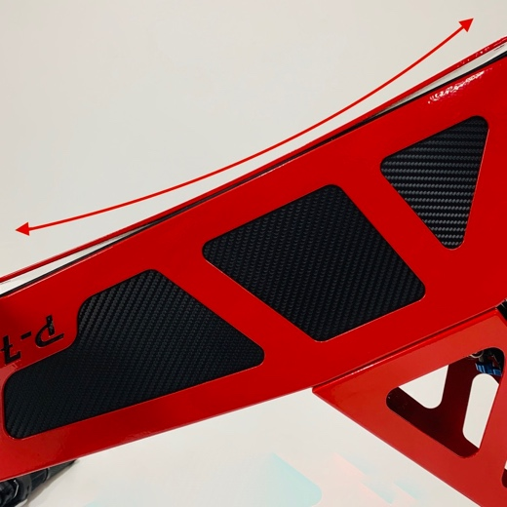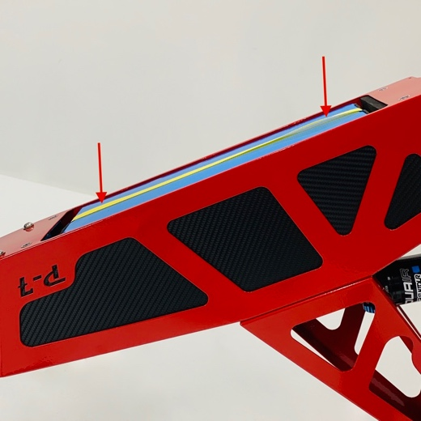

**INSTALL DC-1 JUMPER**

If your bike has come with the battery shipped separately, you will also need to ensure to insert a "jumper" to the DC-1. The DC-1 utilises a small battery to power the background settings whilst the bike is off, i.e time and disabling the security code.

The jumper is found in the same bag amongst the Owner's Manual and bike keys, this needs to be inserted into the underside of the DC-1 as shown below.



The DC-1 won’t store any ride or diagnostic information if the jumper is not installed. Make sure the jumper is installed if planning to ride the bike in the near future.

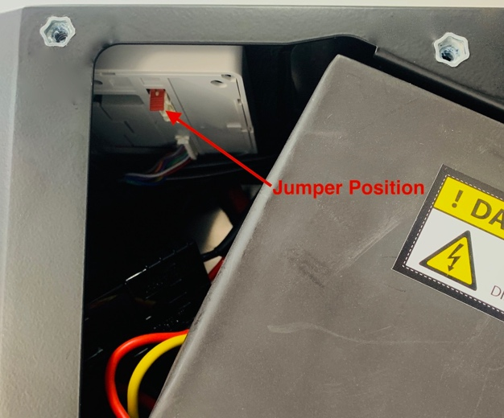

**Battery**



Do not disassemble the battery case under any circumstances. Tampering with the battery will void warranty and could lead to explosions causing serious injury or death.

Do not use any charging unit other than the approved Stealth battery charger. Failure to do so will void the warranty and could result in death or serious injury

**RANGE**

Performance and mileage of the battery varies depending on ambient temperature, terrain, rider weight and how aggressively you ride.

The typical maximum range of the P-7/R is between 100-150km (62-93 miles) depending on battery option, set to economy or 250W mode, with a 75kg rider on a flat roads, minimal wind resistance and slick tires.

There are some actions you can take to ensure maximum capacity from each charge.

* Ensure battery is fully charged before use.
* Only recharge battery when more than 30% has been used. Otherwise charge before use.
* When charging and where possible, allow charger to remain connected to bike and switched on for 30 minutes after charge is complete. The charger may cycle on and off during this time.
* When storing your bike for extended periods (1 month or more), ensure that the battery is kept at 60% charge and disconnect the battery from the bike.

Stealth battery packs have no memory effect. This means that they can be recharged or discharged from any state of charge. Wherever possible keep your battery fully charged.

**CHARGING**

Before heading out on your ride you must ensure the battery is fully charged to achieve the maximum range.

Follow the steps below to charge your Stealth battery:

1. Ensure the bike is switched off and the charge port is clean and dry.
2. Connect the charger to the wall socket. A red and a green light should illuminate.
3. Now connect the charge plug to the charge socket located on the front LHS of the bike. The charger should then display a Red light, and the charge cycle should commence.
4. The complete charge period should last approximately 2-3 hours (depending on model). At the end of the charge cycle the charger will illuminate a Green light. This indicates that the battery is fully charged and the charger can be disconnected.



Fully charged

If your battery charger has a switch to operate on 2 different voltages (120V/240V) ensure that the setting matches the mains power supply. The voltage depends on the region/country.

Do not leave charger running overnight, resume charging before next ride if necessary.

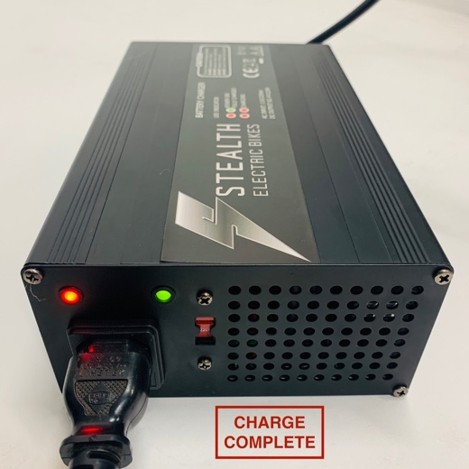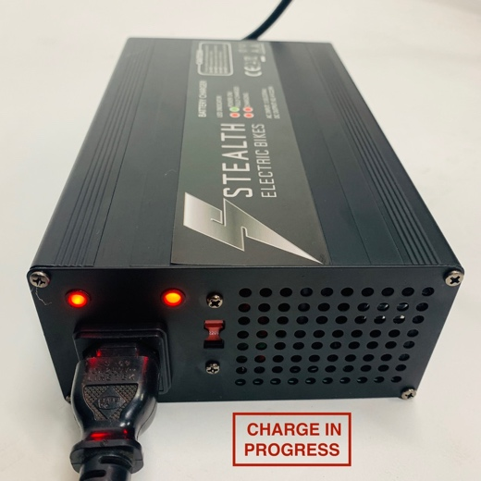

**STORING BATTERY AND STEALTH BIKE FOR LONG PERIODS**

If the bike is going to be stored for periods of more than one month, the battery needs to be disconnected from the bike at 80% of capacity for optimum battery life.



Proper storage of the battery is recommended if is not going to be used for long periods of time. Improper storage can result in significantly reduced battery performance

Follow these steps to ensure best battery and bike care when storing:

1. Fully charge the bike and then ride the bike until the DC-1 display indicates 80% of battery life.
2. Use a 4mm Allen key to remove the 4 screws securing the battery door cover of the bike.
3. Separate the large battery connector.
4. Remove jumper from the underside of the DC-1 display and tape it to the inside of the frame so that it is not lost.
5. The bike will need to be fully charged (and ridden until it shows 80% for optimum storage) every 6 weeks of storage. As the battery will slowly discharge over time, failure to do this will damage the battery.

Due to the weight and unique style of your Stealth Bike, only an approved Stealth Electric Bike rack should be used to carry your bike. Bikes should be properly secured in an upright position to prevent damage to the controls and cranks during transport.

Do not expose your bike to extreme highs or lows of temperature. Ideally the bike should be stored at temperatures between 10˚C and 35˚C.

Avoid storing the bike in wet or damp areas or areas that are prone to extended periods of direct sunlight.

If you are planning to ship your bike, make sure it is properly packed and protected to avoid damage.

to ship your bike, make sure it is properly packed and protected to avoid damage.

**Your First Ride**

Before exposing the bike to difficult terrain and traffic, it is extremely important that you familiarise yourself with the response of the throttle, gears, suspension and brakes. It is recommended that you do so in a large flat area with no obstacles, such as an empty car park.

Avoid heavy acceleration for the first 3 rides to ensure maximum overall battery life.

**ALWAYS RIDE WITHIN YOUR LIMITS!**



### **BRAKING**

The brakes are the most important component of the bike. If you are unsure how to set up your brakes, contact a stealth dealer or bicycle mechanic to ensure efficient, ergonomic and safe braking.

Independent hydraulic front and rear brakes are fitted to all Stealth models. The rear brake is controlled by left-hand brake lever and the right-hand brake lever controls front brake as default. The brake levers can be swapped over by contacting your local Stealth dealer. The hydraulic brakes are powerful but are not fitted with the ABS technology found in cars. It is important to modulate your braking for maximum traction and control. This can only be done by becoming familiar with the

brakes in a wide, open area. The brakes may also need some bedding-in before full braking power can be achieved, this is usually done with several cycles of moderate braking to a complete stop.

Magura MT brakes come with adjustable lever throw position. You may also adjust the angle of the lever by repositioning the master cylinder on the handlebar to your desired position.

Front and rear brake callipers are pre-adjusted from factory and normally would not need any further attention. However if you do find the wheels to drag on the brakes simply reposition the brake calliper using a 5mm Allen Key.

For more information and instructions on Magura MT brakes you can find the Owner's Manual [here](https://www.magura.com/media/922405/mt_2017_en.pdf).



When adjusting brake caliper and master cylinder clamp, ensure they are re-torqued to the correct specifications before riding.

**THROTTLE**

The throttle is located on the right-hand side of the bike which regulates the power delivered to the wheel and ultimately the speed of the bike. Simply gripping and twisting the throttle towards you will accelerate the bike.

Minimise heavy acceleration for the first 3 rides for the “brake in period”. This will help minimize the load placed on the battery cells, which will help to prolong the life of the battery pack and at the same time help the cells to operate at their full potential.

Before exposing the bike to difficult terrain and traffic, it is extremely important that you familiarise yourself with the response of the throttle. It is recommended that you do so in a large flat area with no obstacles, such as an empty car park.

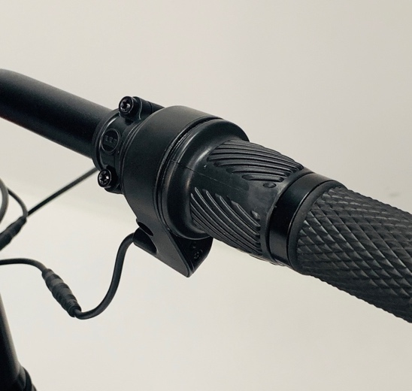

**SELECTING GEARS**

Stealth P-7 and P-7R models use a twist shift mechanism to select gears. The twist shift is situated on the left-hand side of the bars. The P-7/R uses a derailleur to move the chain onto different size sprockets to change the gear ratio as you would find on any normal mountain bike with derailleur

gears. Rotating the twist shifter forwards reduces the gear ratio and allows you to ride up hill more easily. Rotating it rearward increases the ratio and is suitable for pedalling higher speeds. In order for proper and smooth gear changes ensure that you are backing off the pedal pressure before making the shift.

If gear changes are not precise or smooth it is advised to have it looked by a skilled bicycle mechanic to adjust and service.

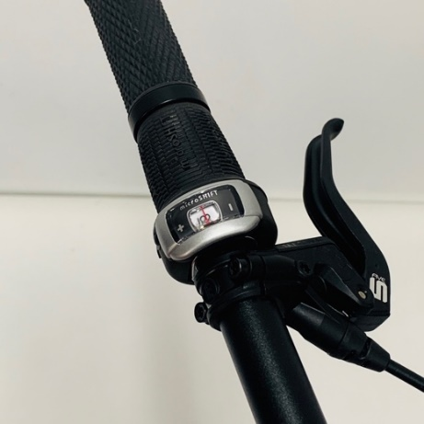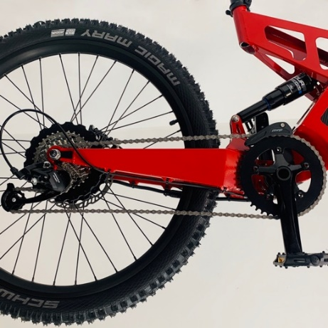

**ADJUSTING SUSPENSION**

Depending on the model of fork and shock equipped with the bike, it should feature at least rebound and preload adjustments. These adjustments, as well as compression and air spring pressure can greatly affect the ride characteristics of the bike and are designed to maintain traction with the ground.

To get the best out of your suspension adjustment should be guided by the user manual from the suspension manufacturer. Hardcopy manuals are supplied with the bike. Electronic manuals are found on the same USB as this Owner’s Manual.

Suspension is a key component of your Stealth Bike. Fork stanchions and preload adjustment should be checked periodically and adjusted to suit the riders preferred setting. Always follow the manufacturer’s instructions for use and maintenance.

Rear Shock

1. Unlock the preload adjustment by loosening the bottom lock ring on the spring unit using a C spanner.
2. Rotate the spring and collet to increase or decrease the spring tension.
3. Re-lock the preload adjustment by turning the bottom lock ring clockwise until it locks against the spring retaining ring.
4. Tighten with C spanner.
5. Increase or decrease the rebound damping by turning the red rebound adjuster dial in the direction required (as indicated on the top of the shock body).
6. Increase or decrease the compression damping by turning the blue compression adjuster dial in the direction required (as indicated on the bottom of the shock reservoir).

**Front Suspension/Forks**

Refer to the manufacturers specific Owner’s manual for adjustment details for all forks. Digital manual can be found [here](https://www.srsuntour.com/fileadmin/user_upload/Downloads/Consumer/Bike/Owners%20manuals/General_Fork_Manual/EN_MY22_SUS_fork_user_manual-20210820.pdf).

**COMFORT and BIKE POSITION**

In the interest of comfort and efficiency, components such as the seat, seat post, stem, handlebars and brake levers should be adjusted to specifically suit the rider. This should only be done with the consultancy of or by a skilled bicycle mechanic.

**DC-1 and Electronic Security**

The DC-1 is used to display real time information to the rider and to manage the bikes power output.

The DC-1 has three pages. Home, Info and Settings. To navigate from one page to the next, press the menu button. The current page is highlighted in the top left corner of the screen. (Note: When the DC-1 is on the Settings page the throttle is disabled, indicated by the power off icon). The B-52, F-37 and H-52 have the same formatting, however, the P-7 uses a newer display with slight variances. Instructions are given for both in the following section.

**ELECTRONIC SECURITY**

The DC-1 will require the owner to use a 4-digit security pin to turn the bike on. This number is unique to the bike and must be obtained by contacting Stealth once your bike is assembled. Please contact Stealth via email or phone and provide us with your name and bike number:

Email: [sales@steatlhelectricbikes.com](mailto:sales@steatlhelectricbikes.com)

Ph: +61 (0) 3 9574 0257

To enter your security pin:

1. You must first turn the bike on.
2. Once the screen below is displayed, use the up and down directional buttons to change the flashing digit to the correct number.
3. Then press the OK button to move to the next digit.
4. Once the 4th digit is correct, press the OK button to enter the pin.
5. Once the correct pin is entered, the bike is ready to ride.

The bike will require the security pin to be entered each time that the bike is turned on. To change this, please navigate to the Settings page (as described below) and select Electronic Security. You will then have the following options:

* Lock Bike: This requires the security pin to be entered each time the bike is turned on. Note: if the jumper is not installed, you will have to enter the security pin each time that a bike is turned on.
* Auto Lock Bike: Turning this on will require the security pin to be entered after an inactive period set by the user. Note: if the jumper is not installed, you will have to enter the security pin each time that a bike is turned on.

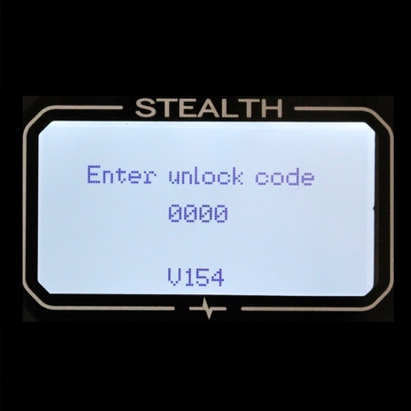**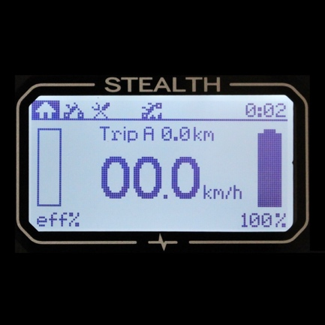DC-1 SCREEN – HOME**

## **Mode**: Indicates if bike is in Economy or Competition mode. Competition mode derestricts some of the performance of the bike. Once the bike has been derestricted, these modes can be toggled between by quickly pressing the OK button.

* **Menu screen**: Indicates the current screen being viewed.
* **Speed**: Displays current moving speed.
* **Battery level**: Displays remaining battery level.
* **Battery percentage**: Displays percentage of remaining battery capacity.
* **Warnings**: A warning icon will only be displayed when one or more of the following limits are reached:
  + Speed limit (**S**): is displayed when the Competition mode speed limit is reached. (In Competition mode, the speed limit can be adjusted, see Competition mode). Derestrict at own risk.
  + Power limit (**P**): Is displayed when the Competition mode power limit is reached. (In Competition mode, the power limit can be adjusted, see  Competition mode). Derestrict at own risk.
  + Temperature limit (**T**): The temperature warning symbol is displayed, and an alarm will be heard when the motor or controller are approaching their temperature limit.
* When the alarm has sounded, power to the motor will be reduced until the component cools sufficiently for full power operation to return.
* If, however, the temperature of the motor and controller continue to rise to an unsafe level, a secondary alarm will sound indicating that the power will now be shut down completely and will resume when the temperature returns to a safe level. (Motor and controller temperature indicators can be seen on the info screen).
  + Low Volts (**V**): Indicates that the battery voltage is low and the battery will require charging soon. When **V** is displayed, the power and speed will be reduced to prolong range and allow the operator to ride home before the battery is completely discharged.
  + Economy (**E**): Is displayed when the remaining battery capacity is low. When the **E** Icon is displayed, the bike will revert to slower, less powerful profile to conserve the remaining battery.
* **Power off**: Displayed when the power to the motor has been disabled. This can occur from the following conditions:
  + The controller or motor has reached its maximum operating temperature. (Motor and controller temperatures can be seen on the info page).
  + The display is in the settings menu.
* **Clock**: Displays current local time. (Note: Clock operates in 24-hour time format).
* **Power usage level**: Displays a graphical representation of how much of the available power is being used at any given time. (In Competition mode, the maximum power limit can be adjusted, see Competition mode). Derestrict at own risk.
* **Power usage**: Displays a numerical reading of how many watts are being consumed at any given time.
* **Trip data**: to navigate between trip data, use the up and down directional buttons.
* **Trip A**: displays the total distance travelled since last Trip A reset (hold the OK button to reset).
* **Trip B**: displays the distance travelled on the current battery cycle.
* **Trip A time**: displays current ride time since last for Trip A distance.  (Zeroed when Trip A is reset).
* **Range**: approximate distance left of battery cycle. Caution: this is calculated on current use and therefore will fluctuate with ride style, so it should be used as an estimate only.

**DC-1 SCREEN – INFO**

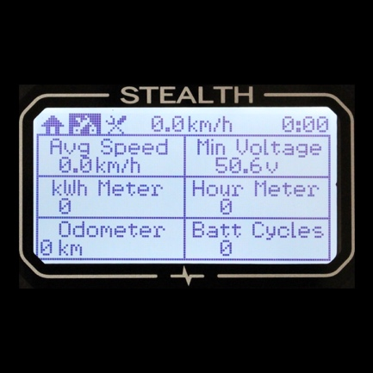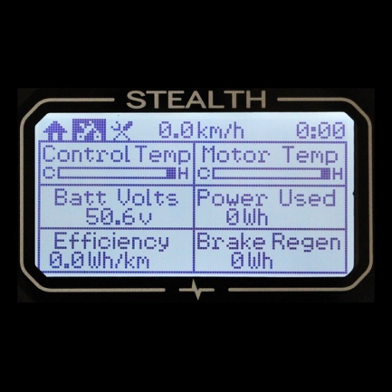The info screen shows detailed data relating to the bikes performance. This information is displayed on two pages. To move between these two pages, use the up or down button. Below is the information displayed.

* **Control Temp**: Indicates temperature of the controller.
* **Motor Temp**: Indicates temperature of the motor.
* **Batt Volts**: Displays the voltage of the battery.
* **Power used**: Displays power used for the trip. This includes power recovered by regen braking. Resets with battery charge.
* **Efficiency**: Displays the average power used (Wh) per distance unit (km or mi). Resets with battery charge.
* **Brake Regen**: Displays power recovered by regen braking. Resets with battery charge.
* **Avg Speed**: Displays average trip speed (including static time). Resets with Trip A.
* **Min Voltage**: Displays the minimum voltage reached during the trip. Resets with battery charge.
* **kWh Meter**: Displays total battery kWh consumed.
* **Hour Meter**: Displays total riding time.
* **Odometer**: Displays total distance travelled by bike.
* **Batt Cycles**: Displays total number of battery cycles.  Increments with battery charge.

**DC-1 SCREEN - SETTINGS**

The settings page allows you to change the setup of your Stealth Bike. The up and down directional buttons scroll the selection tool. To enter a setting, press the ok button. Once within a setting, press “OK” to change the setting then the up and down directional buttons scroll options and are used to change values. The “OK” button then saves the setting and exits the screen. Note: The settings screen cannot be accessed when the bike is moving.

* **Select Power Mode**: Derestricts the bike (see Competition mode). Once derestricted this can be used to change between Economy and Competition profiles. "Not Used" is displayed for P-7 models.
* **Adjust Limits**: Allows adjustment of power and speed limits on Competition profile.
* **Adjust Clock**: Allows the operator to set the time clock. (Note: Time is in 24hr display format).
* **Tyre Size**(circumference): For accurate speed, distance and range calculation the tyre sizes that are fitted to the bike must be selected here. This can be done by entering either Razorbacks or Crazy Bobs tyre size, as shown, or if another tyre is used, the operator can enter a custom value.
* **Speed Unit**: Allows a choice of mph or km/h.
* **Backlight/Sound**: Backlight dimmer and sound on or off.
* **Manual Reset**: The system resets automatically after charging the battery. Manual reset allows the user to manually reset all data. **CAUTION**; if a manual reset is performed when the battery is not at full charge the battery indicator will be incorrect.
* **Electronic Security**: This gives you the option to lock your bike (your security pin will be required each time your bike is turned on) and to turn the auto lock on or off. The auto lock requires your security pin after a period of inactivity selected by the user. Note: if the jumper is not installed, you will have to enter the security pin each time that a bike is turned on.
* **About Stealth**: Displays bike build number and software version.
* 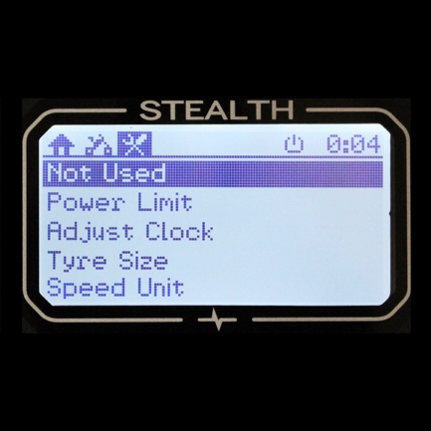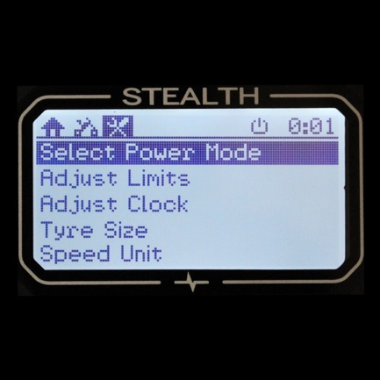**Diagnostic Data**: Displays diagnostic data (see Troubleshooting).

# **WHILE RIDING**

When the key is turned on the DC-1 will show a start-up screen for a few seconds before displaying the “Home screen”. Once the “Home screen” is displayed, and the power off icon has switched off, the throttle becomes active and the bike is ready to ride.

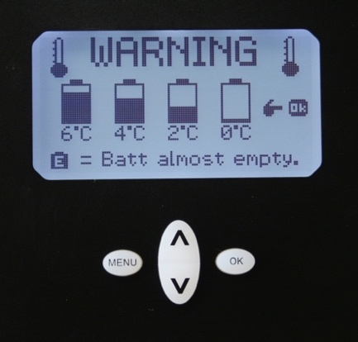If the ambient temperatures are quite cold, the following screen may appear to remind the rider that the battery capacity may be reduced as a result of the cooler temperatures.

**TRIP INFORMATION**

While riding, the Home Screen will display the current speed, power usage and battery life as well as some trip information. Trip information can be scrolled through using the up and down directional buttons.

* **Trip A**: Continuously records trip distance so it can be used to measure distance over a time frame of the rider’s choice (eg. A weekends riding). To reset, hold the “OK” button whilst Trip A is displayed on the screen.
* **Trip A time:** Displays the ride time for Trip A. It is reset when Trip A is reset.
* **Trip B:** Automatically resets with each battery cycle, therefore giving the distance travelled on the last battery charge. Use this to compare how different ride styles affect range.
* **Range:** Gives an estimate of the remaining distance available.

**Note:** Because Range is highly dependent on use, it is important to understand that this is an estimate based on the battery usage up to that point. If the latter stages of a ride involve more uphill, or the rider is putting in less effort the range will reduce, and can do so dramatically.

## **POWER MODES AND LIMITS**

The DC-1 has several limiting features, both manual and automatic. These limits are used to change the characteristics of the bike as well as protecting components from over use.

Stealth P-7 models are locked to your country’s legal road limits according the e-bike regulations, the power and speed is fixed and can not be adjusted.

**MANUAL LIMITS**

* **Economy mode**: New bikes are delivered restricted to Economy mode. The power output of the Economy mode varies depending on country of purchase, please ask your dealer for further information. The power limit in Economy mode cannot be modified. **WARNING: Economy mode may not be street legal, check local laws before riding on public roads.**
* **Competition mode**: The bikes may be derestricted allowing access to the Competition throttle profile. **CAUTION**: Competition mode utilises the full power of the bike, derestrict at your own risk.

Once the bike has been derestricted, toggling between Competition and Economy profiles can be done by momentarily pressing the OK button while on the Home screen. The Competition power and speed limits can be manually adjusted as required. To do this, navigate to the Settings page. Select “Adjust Limits” and follow the on-screen instructions to change the limits.

When riding, if the speed or power limit is reached, the Speed or Power (“**S**” or “**P**”) limit icons will appear on the home screen. Using these you can accurately adjust the Competition limits to suit your needs.

### **AUTOMATIC LIMITS**

* **Temperature Limit**: the DC-1 monitors the temperature of the motor and controller while the bike is in operation. If a temperature approaches the limit, the DC-1 will emit a warning and display the Temperature limit icon **“T”**, while also restricting the bike’s power. The temperatures of the motor and controller can be viewed on the Bike **Info** page.
* **Power Cut:** If the temperature reaches the limit the Power Cut icon will be shown. All power to the motor will be cut until the bike cools sufficiently. The temperature of the motor and controller can be viewed on the info page.
* **Voltage Limit:** When the voltage limit icon” V**”** is displayed, the power level is automatically limited to prevent the battery level dropping too low in order to maximise the remaining range of the battery.
* **Battery Limit**: When the battery capacity is low the DC-1 will emit a warning alarm and display the **“E Mode”** icon. Limit aggressive throttle use, and increase pedal efficiency to maximise the remaining range. This will help the rider reach their destination without losing all power. **Recharge the battery as soon as possible.**
* **Battery Monitor:** When the battery capacity reaches 0%, the battery monitor may shut down the bike to prevent the battery from over discharging. **Recharge the battery as soon as possible**.

**COMPETITION MODE (Exclude Stealth P-7 models)**

The power limits imposed by the DC-1 can be derestricted. Once derestricted, the operating mode can be changed between Economy and Competition profiles by pressing the Up Arrow and OK button in quick succession while on the home screen.

To derestrict the DC-1, turn bike on and:

|  |
| --- |
| 1. Press the MENU button twice so that the settings page is displayed. |
| 1. Press the OK button to select “**Select Power Mode** “. 2. A warning screen is displayed, press OK to continue or MENU to exit. |
| 1. Press the directional buttons to change the unlock code to **115** and then OK to accept.   Your bike is now in Competition mode. **CAUTION: The throttle response is now much faster.**  **Turn throttle slowly, until you get used to the power**. While the home screen is displayed, it’s possible  to quickly change between Economy and Competition modes by pressing the Up Arrow and OK button in  quick succession. The mode icon at the top of the Home screen will display the current mode.  **NOTE: The change from Economy to Competition modes can only be made when there is zero**  **throttle input.**  The speed and power limits of the Competition mode can be adjusted to reduce speed and power if required.  To adjust these settings:   1. Use the MENU button to navigate to the settings page 2. Use the directional buttons to highlight “Adjust Limits” and OK to select 3. Follow the on-screen instructions to adjust the limits.   **Derestricting the bike may not be street legal in some countries, check local laws before doing so. Stealth Electric Bikes takes no responsibility for any fines, detainment, damage to property and injury that may be caused by the bike. The derestriction of a bike creates a record and can be proven.** |

**Riding Techniques**

**AVOIDING DAMAGE**

Even though your Stealth Bike has been constructed using the highest quality materials, if you exceed the limit of strength of your bike or a given part, it may fail. After any high force load, thoroughly inspect all the parts of your bike. High force loads include crashes, but you don't necessarily have to crash to put a high force load on your bike.

1. Do not ride beyond your limits or the design limits of the bike. If you are unsure of the limits of the bike, consult your dealer.
2. Avoid improper braking by understanding and practicing proper application of your brakes.
3. Do not ride while intoxicated or while using medications which might affect your ability to ride.
4. Never ride barefoot, with sandals or thongs/jandals.
5. Do not ride with loose objects attached to the handlebar or any other part of the bike.
6. Do not carry passengers.
7. Never ride your bike whilst holding onto another vehicle.

### **OFF ROAD RIDING**

1. Ride only on designated trails. Avoid large rocks, branches, or depressions. When approaching a descent, reduce speed, keep your weight back and low whilst using the rear brake more than the front.
2. Always respect private property and remember you may be sharing the trail with others. Respect their rights. These bikes allow you to access many places that are not usually accessible by conventional modes of transport. The high torque and smooth power delivery helps to minimise the footprint left on loose and slippery surfaces. In some instances, however, there is the potential for the tyres to break traction or slide. Please help to preserve environmentally fragile areas and help to keep trails open for future use by riding sensibly and avoiding unnecessary brake slides and wheel spin where possible.

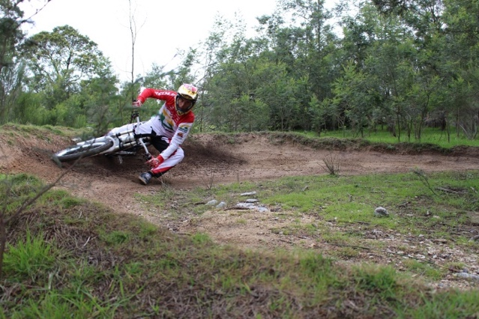

**RIDING EFFICIENTLY**

The Stealth B-52, Stealth F-37 and Stealth P-7 have the versatility to take you to places that you might not usually go. Being a hybrid, Stealth owners have a lot of flexibility in how they manage their power consumption for any given ride through different combinations of the pedals and the throttle. On long distance rides, getting home while there’s still a little charge in the battery is important.   
  
Following a handful of basic guidelines will help you improve your efficiency, extend your range significantly and make the most of your battery charge cycle.  
  
Riding technique, throttle and braking control, stop/starts, terrain and top speed are all factors that can almost double your range if done properly.  
  
Your display is the most important tool when it comes to maximising efficiency. On the bottom, left hand corner of the main screen is your instantaneous Watt reading. The general idea is to keep the Watts as low as possible at all times. By twisting the throttle, you should be able to see the Watts climb and then drop away in synchronise with the level of acceleration that you feel. By making small adjustments to the throttle position, you should be able to see the Watts fluctuate.   
  
Pedal more…. Even if only in short bursts. Choose a gear that is suitable to the speed of the bike and stand on those pedals. Not only will you accelerate faster, you’ll reduce the load on the electrical system and get the workout that you need.   
  
As most of us know, good technique not only helps us go faster, but also use less energy … especially in the dirt. Our extensive testing has shown that two riders of equal ability, on the same model of bike, on the same trail, traveling at the same speeds can differ in their power consumption by up to 10%, based purely on how they ride. Just like a mountain bike, the secret to using as little energy as possible is to keep it smooth and keep it flowing. Use the brakes and throttle less, carry your speed and let gravity do as much of the work as possible. (There is limitless material on the web about riding techniques and body position etc.) Make good use of the gears and get some pedal strokes in at every opportunity. Short bursts of high intensity pedalling when accelerating out of a corner or climbing hills can make a significant difference.  
  
Throttle control is vital in improving efficiency. As a basic rule of thumb, the more that you twist the throttle, the more power you will use. This theory can be backed up by simply watching the display as you change the throttle position. By suddenly twisting the throttle, power consumption will temporarily spike and over the duration of a long ride, a heavy right hand will shorten your ride time. Gently rolling the throttle on avoids huge power draw and can represent that few extra per cent that you need to get you home. When climbing a hill, backing off the throttle slightly can make a huge difference in to your Watts reading while only making an incremental change to your speed. By adding some pedal strokes in the correct gear, you should see the Watts drop even further.  
A lot of energy is wasted during braking. Judging your speed and approaching corners correctly will help to minimise the reliance on the hydraulic brakes and allow you to maintain speed out of a corner. This translates to less throttle and less wasted power as you exit the corner.  
  
Regen braking is your battery’s best friend. Wherever possible, regen should be used. Using the regen on long downhills and for slowing down in general will recover some of the bikes kinetic energy and feed it back in to your battery. In a normal hydraulic braking system, this kinetic energy is dissipated as heat via friction and leads to premature wear of your brake pads. In emergency braking situations however, always use the hydraulic brake system.   
  
Stop/starts are probably the fastest way to deplete your battery. Power consumption is at its highest when accelerating off the line. Pedalling while gently rolling the throttle on is the key here. This can certainly be backed up by watching the Watts on the display climb, peak and then drop off again as the bike picks up speed. Extreme acceleration is great fun, but it comes at a price….. Range.  
  
Some terrain can really suck your battery dry. When trying to conserve power, try to avoid soft ground, mud, gravel, steep hills and obstacles. By choosing smooth lines and maintaining your speed, power consumption can be kept at a minimum.  
  
Speed. With speed comes wind resistance (and a few others). The greater the speed, the greater the resistance. The greater the resistance, the more power you will consume. Traveling at speeds below 25mph (40km/h) can greatly influence the duration of your ride. The slower you go, the further you will get.  
  
While there are no set rules on when you should apply any of the above recommendations, we have spent hundreds of hours testing our bikes and collecting data on these points. They are proven to make a substantial difference to range and as you become more accustomed you your bike, eventually riding efficiently will become intuitive, which will allow you to save your battery for the times when you just can’t help going full-throttle.

# **Stealth Bike Care**



This is an electric bike and all care should be taken to avoid excessive water exposure as it will void your warranty and possibly damage your bike.

Stealth Electric Bikes can be ridden in a multitude of environments and weather conditions. While these bikes are water resistant, care must be taken in exceptionally wet conditions and the bikes must never be submerged in water in any way. Rain or snow may cause the metal on your e-bike to corrode and damage the electrical system.



Riding in sand will void your Stealth Bike warranty. The increase power demands on the electrical and mechanical components could result in failure.

## **CLEANING**

High pressure washers should not be used for cleaning. While the bikes are very well sealed, water ingress may occur as a result of high pressure water being forced past seals and into electronic components. This can damage the bike to a point where the component/s are beyond repair. The preferred method for cleaning is with a sponge and warm soapy water.

## **Maintenance Schedule**

## 

Many Stealth service and repair tasks require special knowledge and tools. Do not begin any adjustments or service on your bike until you have learned from your dealer how to properly complete them. Improper adjustment or service may result in damage to the bike or in an accident which can cause serious injury or death.

Your Stealth Bike should be cared for and maintained according to the following schedule.

### **EVERY RIDE**

Upon returning from each ride, perform the following checks and repairs.

1. Wipe down your bike and remove excess moisture from mainframe and hub motor. This is essential in maintaining the electrical system of your bike.
2. Charge battery. REFER to Charging procedure pg. 15.
3. Wipe down stanchion tubes. Failure to keep these clean could result in oil loss and damage to your forks.
4. Check suspension fork bolts and clamps to ensure they are correctly secured.
5. Lubricate the chain especially after off road riding. (Silicone based chain lube is preferred).
6. Check the brakes for proper operation.
7. Lubricate chain if required.

NOTE: Visually inspect brake pad thickness periodically for wear. Pads should be replaced when pad thickness is less than 0.5mm.

**EVERY MONTH**

1. Check the tyre pressures and wheels. Replace any damaged components.
2. Ensure that steering head bearings, handlebars and associated bolts are tight.
3. Check the seat and seat post alignment and fasteners.
4. Ensure there is no fouling or excessive wear of wires and cables on the controls.
5. Check the frame for damage. High force loads can damage frame components.
6. Check for loose spokes and replace if necessary.

**EVERY SIX MONTHS**

1. Check derailleur adjustment and lubricate cables
2. Lubricate suspension and shock bushings.
3. Lubricate brake levers.

**Troubleshooting**

If you have any issues with your bike relating to the electrical system, Stealth customer support requires a legible photo of the Diagnostic Data screen. If possible, take this photo while the problem is occurring.

To produce the photo needed, do the following:

1. Turn bike on and ride bike or turn wheel by hand for at least 5 full rotations of the wheel.
2. Press the MENU button twice to navigate to the settings page.
3. Use the directional buttons to navigate to the bottom of the page and the “OK” button to select “Diagnostic Data”

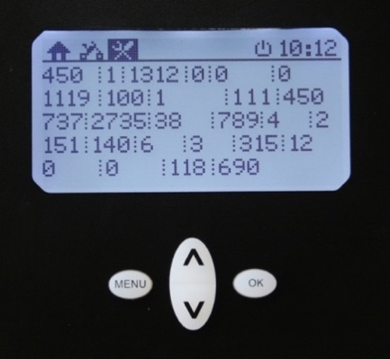

The diagnostics screen will appear for 5 seconds. A photo of this screen is required when communicating with Stealth customer support.

## **BMS RESET PROCEDURE**

The BMS (Battery Management System) fitted to your bike maintains a healthy battery by monitoring each individual cell inside the battery pack and ensuring that the battery operates within its safe working limits. If a fault is detected, the BMS will override all other systems within the bike and shut down in order to protect the battery pack. This condition may be caused by overcharging, over discharging, short circuit, overheating, physical damage or cell imbalance (if a cell is defective).

In the event of a BMS shut down, there will be very little power present within the system. Turning the ignition key on may have no effect and connecting the charger to the bike will also be ineffective.

In this instance, a BMS reset may be necessary. The following steps will initiate a BMS reset and in most cases restart the BMS.

1. Remove side panel.
2. Disconnect main battery cable (Large rectangular connector).
3. Leave charge connector (small green/red connector) in place.
4. Connect charger (the charging process should begin).
5. Reconnect the main battery cable.
6. Reinstall the side panel.

# **Appendix 1: Component Manuals**

|  |  |  |
| --- | --- | --- |
| **Manufacturer** | **Component** | **Owner’s Manual** |
| Suntour | Forks | <https://www.srsuntour.com/fileadmin/user_upload/Downloads/Consumer/Bike/Owners%20manuals/General_Fork_Manual/EN_MY22_SUS_fork_user_manual-20210820.pdf> |
| Magura | Brakes | http://www.magura.com/en/components/techcenter/?p=2580 |

# **Limited Warranty**

This product has been manufactured and tested to the highest quality standards by Stealth Electric Bikes Pty Ltd. This Limited Warranty offered by Stealth covers defects in material or workmanship in new Stealth products. This warranty extends to the original purchaser only and is non-transferable. Only consumers purchasing Stealth products from authorized Stealth retailers or resellers or through the Stealth website may obtain coverage under our limited warranties.

**WHAT IS COVERED?**

Stealth Electric Bikes warrants this product against defects in material or workmanship as follows:

Stealth Electric Bikes will replace at no charge for parts only or, at its option, replace any product or part of the product that proves defective because of improper workmanship and/or material, under normal installation, use, service and maintenance. If Stealth is unable to provide a replacement and repair is not practical or cannot be made in a timely fashion, Stealth may elect to refund the purchase price in exchange for the return of the product.

**HOW LONG DOES THE COVERAGE LAST?**

Our warranty periods are 10 years for B-52, F-37 and H-52 frames and 12 months for all other components from the documented date of purchase, depending on the type of product and where it was purchased.

**WHAT OUR WARRANTY DOES NOT COVER?**

Our warranties do not cover any problem that is caused by:

1. Conditions, malfunctions or damage not resulting from defects in material or workmanship.
2. Conditions, malfunctions or damage resulting from normal wear and tear, improper installation, improper maintenance, misuse, abuse, negligence, accident, alteration or extreme climates.
3. Accessories, connected materials and products, or related products not manufactured by Stealth Electric Bikes.

Our limited warranties are void if a product is returned with removed, damaged or tampered labels or any alterations (including removal of any component or external cover).

**HOW TO FILE A CLAIM?**

Stealth Electric Bikes will not provide any warranty coverage unless claims are made in compliance with all terms of the controlling warranty statement included with your product and you follow proper return procedure. To request warranty service, you will need to contact the Stealth Customer Service Department and clearly provide information relating to the:

The sales receipt or other evidence of the date and place of purchase.

1. Full name, contact details (including telephone number and email address).
2. Build number of the bike.
3. A description of the problem.
4. Images or video evidence of the problem.
5. Delivery of the product or the defective part, postage prepaid and carefully packed and insured, to Stealth Electric Bikes or an agreed dealer.

When warranty service is completed, any repaired or replacement product or part will be returned to you (postage prepaid).

**Stealth Electric Bikes reserves the right to inspect any defective components or products to determine whether a repair or replacement is required.**

**REPAIR OR REPLACEMENT (OR, IN LIMITED CIRCUMSTANCES, REFUND OF THE PURCHASE PRICE) AS PROVIDED UNDER THIS WARRANTY IS THE EXCLUSIVE REMEDY OF THE PURCHASER. STEALTH ELECTRIC BIKES NEITHER ASSUMES NOR AUTHORIZES ANY PERSON TO CREATE FOR IT ANY OTHER OBLIGATION OR LIABILITY IN CONNECTION WITH THIS PRODUCT.**

**STEALTH ELECTRIC BIKES SHALL NOT BE LIABLE TO PURCHASER OR ANY OTHER PERSON FOR ANY INCIDENTAL, SPECIAL OR CONSEQUENTIAL DAMAGES, ARISING OUT OF BREACH OF THIS WARRANTY OR ANY IMPLIED WARRANTY (INCLUDING BUT NOT LIMITED TO ANY IMPLIED WARRANTY OF MERCHANTABILITY).**

**HOW DOES AUSTRALIAN LAW APPLY?**

Our goods come with guarantees that cannot be excluded under the Australian Consumer Law. You are entitled to a replacement or refund for a major failure and compensation for any other reasonably foreseeable loss or damage. You are also entitled to have the goods repaired or replaced if the goods fail to be of acceptable quality and the failure does not amount to a major failure.

For more details visit our website at www.stealthelectricbikes.com